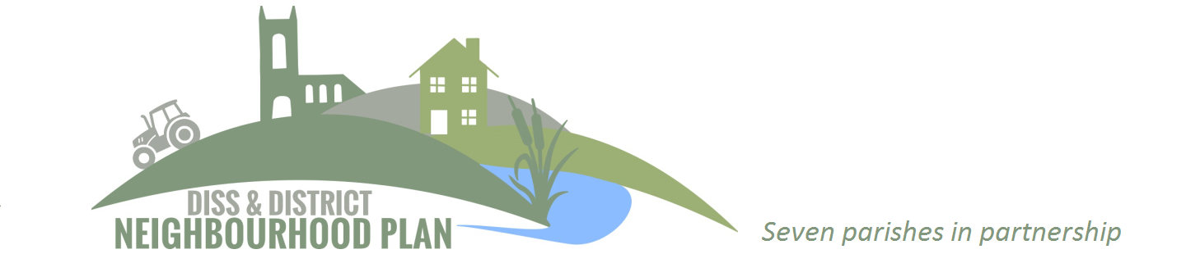Diss & District Neighbourhood Plan community consultation goes online
The Diss & District Neighbourhood Plan, which covers seven parishes across two local authority areas, launches its ‘Issues and Options’ community consultation questionnaire.
Led by a Steering Group comprising representatives from the parishes involved, which are Diss, Roydon, Palgrave, Scole, Brome & Oakley, Burston & Shimpling and Stuston, work has been underway to identify potential sites for future development, plus key community assets such as important views and landscapes, non-designated heritage assets, local green spaces and footpath and cycleway networks.
“Thanks to the work of local volunteers, we are now in a position to consult with the local communities involved in developing the Plan,” confirms the Steering Group Chair, Mid Suffolk Councillor David Burn,
“We are inviting everyone to complete an online questionnaire covering key elements of the Plan including proposals for sites in the area for housing. A postcard has going out to every household with details of how to take part in this important questionnaire, and we are really looking forward to getting the results and seeing what the communities think should be included in their plan.
“Neighbourhood plans are, in effect, local planning documents that can shape how the area develops in the years to come. They are a real opportunity for the community to have a voice when it comes to development in the area.”
The questionnaire is available to complete online at www.ddnp.info and whilst paper copies are available on request from local parish offices, residents are encouraged to complete it online. “It had been hoped to have displays and presentations in Diss and the surrounding parishes, with Steering Group members on hand to answer questions from the public,” explains Cllr Simon Olander, a member of the Steering Group and Leader of Diss Town Council. “But given the current situation we are all facing with Covid-19, this just isn’t possible right now, hence us having to choose to have the questionnaire online. We will however aim to have plenty of face to face consultation across the Neighbourhood Plan area as soon as it’s safe to do so.”
It’s hoped to start drafting the Neighbourhood Plan later in the year, with further community consultation planned for early 2021.
The deadline to complete the survey is Friday August 14th.
END
Contact for more information: contact@ddnp.info David Burn, Chair of the DDNP Steering Group: d.burn@ddnp.info / 07889 391414

