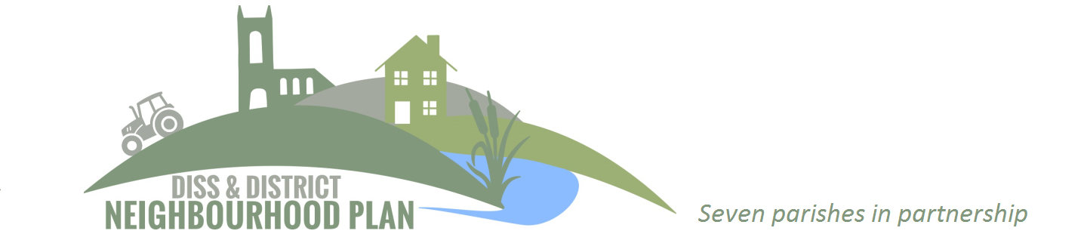

Major Modifications Consultation Response Form
If you, or someone you know, is unable to complete the online survey, you can print out this response form, complete it and post it to DDNP, c/o Diss Town Council, 11-12 Market Hill, Diss, Norfolk, IP22 4JZ.
Please ensure your feedback is with Diss Town Council by the deadline date:
Thursday May 5th 2022.

Your Name(s):
Organisation (if applicable)
Your address:

Your postcode:
Your contact preference (email and or phone):

Please indicate which of the following apply, by typing/writing an X next to your answer.
- I live in the DDNP area
- I work in the DDNP area
- I am a statutory consultee
- I am an agent
- I am a landowner
- None of the above

Consent (you must complete this section)
A summary of all comments made will be publicly available. Please note that any other personal information provided will be confidential and processed in line with the Data Protection Act 1998 and General Data Protection Regulations. Diss Town Council (as the lead council) will process your details in relation to the preparation of this document only. The Privacy Statement can be found here.
As part of the Consultation and in line with the new General Data Protection Regulations (GDPR) please confirm that you are happy for the Diss Town Council to pass on your contact details (name, address/email address) onto South Norfolk Council (as the lead Local Planning Authority) so that they can contact you at Regulation 16 consultation. *
I consent to Diss town Council (as the lead council) processing my details in relation to this preparation of the Neighbourhood Plan
Please write/type ‘yes’ against this statement to show you agree:

I consent to Diss town Council passing my contact details to south Norfolk Council (as the lead Local Planning Authority)
Please write/type ‘yes’ against this statement to show you agree:

Please leave any comments you may have in relation to this Major Modifications Consultation Document in the space below. You are welcome to continue on a separate sheet if you need more space. Thank you, your participation in this consultation is very much appreciated.

- Do you have any comments in relation to major modification 1 – Amended Policy: Scale and location of housing growth?

- Do you have any comments in relation to major modification 2 – New Policy: Regeneration of the Waveney Quarter, Diss?

- Do you have any comments in relation to major modification 3 – New Policy: Diss Business Park?

- Do you have any comments in relation to major modification 4 – New Policy: Surface Water Management?

- Do you have any comments in relation to major modification 5 – Amended Policy: Local Green Space?

End of feedback form.

